**Musical chairs TOK essay writing practice**

**Lesson aim:**

To practise structuring a (collaborative) response to a (specimen) essay question.

**For this activity you will need:**

Music or a timer, tables and chairs placed in a ‘horse shoe’, a set of different coloured pens per student.

1. On the essay template, write one of the 2015 essay specimen titles. You need as many templates as there are students in the class. Place the essays on the tables.

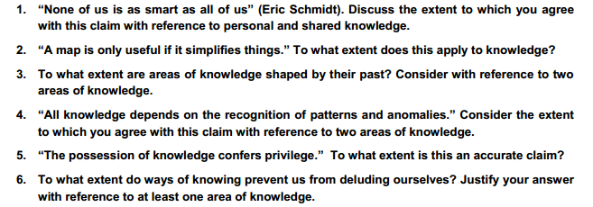

1. Give each student a different coloured pen, so we can re-trace who wrote what.
2. Each student takes place at one essay and starts to write the introduction with the pen of their specific colour.
3. When the music stops, students leave the sheet and move to the next place. They take their pen with them and write on from what the previous student wrote.
4. Continue moving students by stopping and starting the music (or timer) as many times as is necessary to finish the essay.
5. At the end of the lesson each student will receive an essay on which different people have written in different colours. If the task is not completed, they can finish this as homework. As a follow-up activity, students can peer-mark the responses through the attached essay writing mark scheme.
6. The idea is that students read very carefully what others have written. They should think about underlying assumptions and implications and give evidence to support their claims. The essay will not be as thorough as a final TOK essay, but should give everyone a chance to explore how questions can be tackled.
7. Alternatively, Google drive can be used for a different collaborative writing task.

Essay title:

**Introduction** (what does the question mean to you --link to life or a personal reflection/personal & shared knowledge):

**Introduction** (how will you answer the essay question in the essay? – Which TOK and knowledge questions does it raise?)

Introduce a knowledge question – remember the knowledge frameworks can help you.

**Paragraph 1**

Implications

How does the essay question apply to areas of knowledge?

**Paragraph 2**

Think of ways of knowing if you are stuck for ideas

Illustrate ideas with examples

Remember the Knowledge question: think of more relevant knowledge questions if possible.

Paragraph 3

Bring your essay back to title and knowledge question. Are you talking about knowledge?

Think of methodology, language and historical development of areas of knowledge.

**Paragraph 4**

Remember to explore different perspectives. This may be a good time to explore personal versus shared knowledge. Remember to analyse assumptions and implications of perspectives.

claim

Prepare for your conclusion. Don’t finish your essay with a random conclusion at the end.

counterclaim

Give your final summary of how you answer the question. Make sure to give a well-founded, but not a relativistic conclusion. Ensure you have analysed implications of claims/your own suggestions.

**Conclusion**

